January 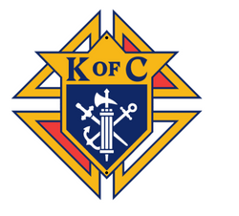 January | 2023
Sunday | Monday | Tuesday | Wednesday | Thursday | Friday | Saturday
1 | 2 | 3 | 4 | 5 | 6 | 7
8 | 9 | 10 | 11 | 12 | 13 | 14
 |  |  |  |  |  | Cleanup 8 – 10 am
15 | 16 | 17 | 18 | 19 | 20 | 21
 |  |  | 3rd Degree meets 7pm |  |  | Order Church Drive Kits for March
22 | 23 | 24 | 25 | 26 | 27 | 28
KofC Breakfast  8 – 10:30 |  |  | 4th Degree meets 7pm |  | March for Life (Washington,D.C.) | Cleanup 8 – 10 am Walk For Life (West Coast)
29 | 30 | 31
 |  | Annual Survey of Fraternal Activity (#1728) due.
PLAN AHEAD: Semi-Annual Audit Due 15 Feb. School of Columbium
(through June) Ash Wednesday 22 Feb. Membership cards distributed by 31 March.
Free Throw Championship Jan. Recruiting Drive TBD
Special Olympics program report due 31 Jan. KofC State Convention 28-30 Apr.
Council Chamber cleanup/remodel events TBD Fraternal Benefits night TBD
Mother’s Day flowers 14 May. Cor meeting initiative TBD
Good Friday fish fry/po’boys 7 Apr. St. Alphonsus Capital Campaign support TBD
Officer’s nominations & elections May/Jun. Chris Nielson Scholarship Award TBD
Exemplifications as required Loaves and Fishes Fish Fry Challenge 18 Feb. 9am Point Cadet Biloxi
Knight’s Mass TBD
Blood Drive/Flu shots TBD

