February 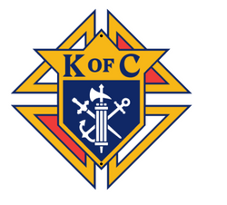 January | 2023
Sunday | Monday | Tuesday | Wednesday | Thursday | Friday | Saturday
 |  |  | 1 | 2 | 3 | 4
 |  |  | 3rd Degree meets 7pm
5 | 6 | 7 | 8 | 9 | 10 | 11
 |  |  |  |  |  | Cleanup 8 – 10 am
12 | 13 | 14 | Semi-Annual 15 Audit due | 16 | 17 | 18
KofC Breakfast  8 – 10:30 |  | Valentine’s Day | 3rd Degree meets 7pm Family of the Month Due to State |  |  | Loaves & Fishes Fish Fry
19 | 20 | 21 | 22 | 23 | 24 | 25
 |  |  | 4th Degree meets 7pm Ash Wednesday |  |  | Cleanup 8 – 10 am
26 | 27 | 28
KofC Breakfast
8 – 10:30
First Sunday of Lent
PLAN AHEAD: Semi-Annual Audit Due 15 Feb. School of Columbium
(through Jun) Ash Wednesday 22 Feb. Membership cards distributed by 31 March.
Recruiting Drive TBD
KofC State Convention 28-30 Apr.
Council Chamber cleanup/remodel events TBD Fraternal Benefits night TBD
Mother’s Day flowers 14 May. Cor meeting initiative TBD
Good Friday fish fry/po’boys 7 Apr. St. Alphonsus Capital Campaign support TBD
Officer’s nominations & elections May/Jun. Chris Nielson Scholarship Award TBD
Exemplifications as required Loaves and Fishes Fish Fry Challenge 18 Feb. 9am Point Cadet Biloxi
Knight’s Mass TBD Blood Drive/Flu shots TBD

